**Test Plan (Maze Game):**

| Test No. | Test Description | Expected Result | Actual Result | Pass/Fail |
| --- | --- | --- | --- | --- |
| 1 | Startup of Program | Program Starts from main menu | Program executes from main menu | PASS |
| 2 | Control Scheme | Program Controls with keyboard arrows | Game responds with keyboard arrows | PASS |
| 3 | Alternate Control Scheme | Program Controls with W,A,S,D Characters | Game Respoonds with W,A,S,D characters | Pass |
| 4 | Enemy AI | Enemy responds to AI | Enemy Responds to AI | Pass |
| 5 | Screen Refresh | Screen Refreshes seemlessly | Screen is sluggish | FAIL |

**Instruction Manual:**

Starting the game.

The game can be started from the main menu by clicking the Maze button.

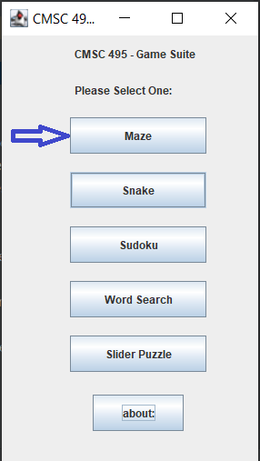

**Gameplay:**

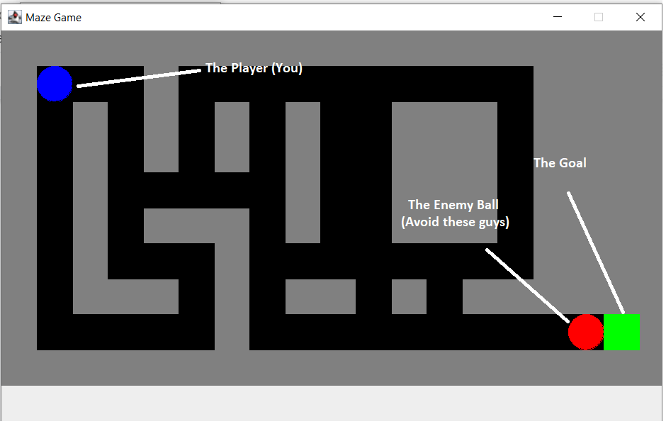

Note: Game is still being coded. The final product will vary from this instance.

The goal of each level is to help the player (the blue dot) to the exit (The green block) while evading the baddies (the red dots). You have an unlimited number of lives but, your final standings will take the number of deaths into consideration so make sure you avoid death as much as possible. You control the player with the arrow keys. Alternatively, you can also use W,A,S,D as both will work. If you are hit by any enemy, the maze level starts again and you will have gained a death point. The score at the end is based on how much time it takes to complete the mazes and the number of deaths the player has recieved.

GOOD LUCK!